Geräte: Voltcraft-Labornetzgerät, Sensor-CASSY, CASSY-Display
Eisendraht (0,2 mm dick, ca. 1 m lang), Konstantandraht (0,3 mm dick, ca. 1 m lang),
Glühlämpchen 6V / 5W, Schichtwiderstand 10 Ω

(1) Eisendraht in Wasser
(2) Eisendraht in Luft
(3) Konstantandraht in Luft

U  in V | 0,5 | 1,0 | 1,5 | 2,0 | 2,5 | 3,0 | 3,5 | 4,0 | 4,5 | 5,0 | 5,5 | 6,0
I₁
in A
I₂
in A
I₃
in A

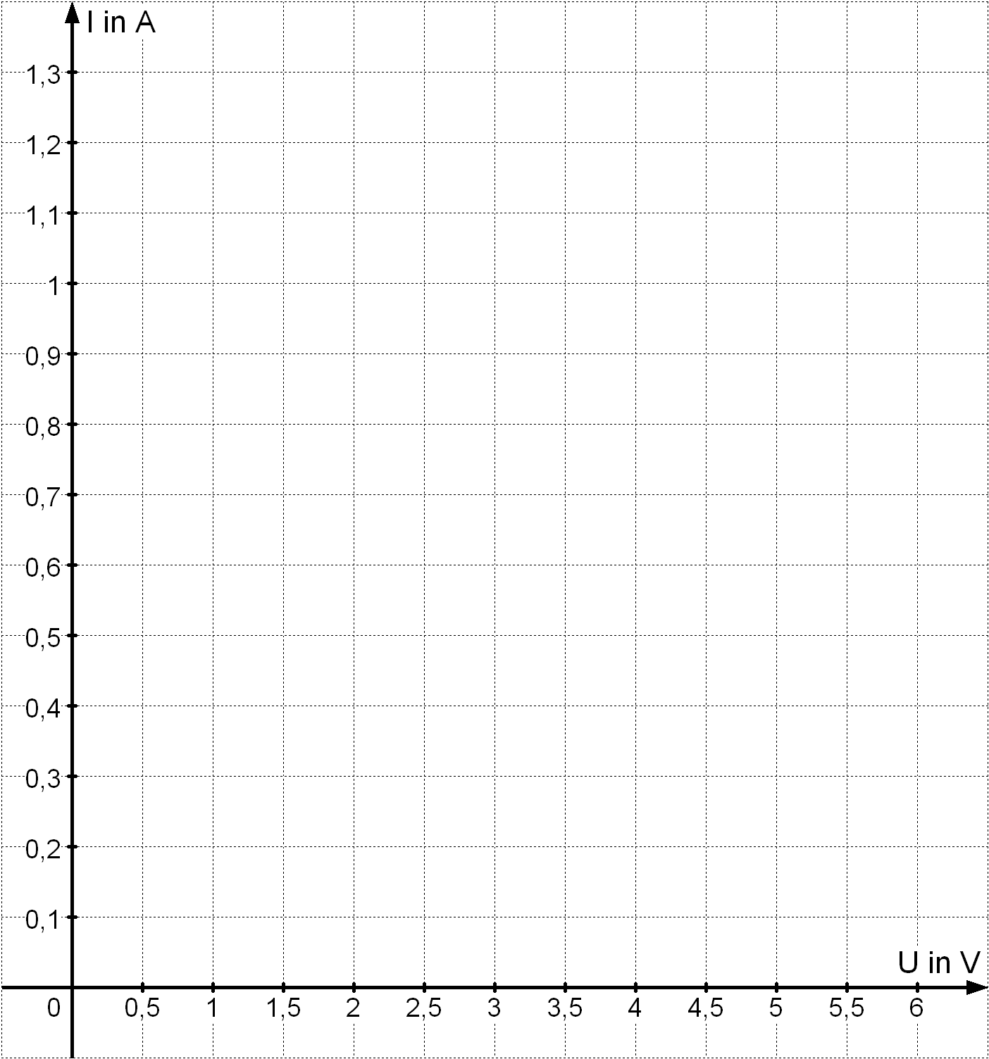

(4) Glühlämpchen 6V / 5W
(5) Schichtwiderstand 10 Ω

U  in V | 0,5 | 1,0 | 1,5 | 2,0 | 2,5 | 3,0 | 3,5 | 4,0 | 4,5 | 5,0 | 5,5 | 6,0
I₄
in A
I₅
in A

